To create our weekly “bulletin” e-newsletter, you will:

- Locate and replicate the previous week’s e-news
– often much of the previous week’s announcements and schedule will be repeated. This will save a lot of time and work.
- Update the replicated copy with current date, announcements, weekly schedule, prayer requests, etc.
- Send your e-news
- After you verify the e-newsletter has arrived in your mailbox, go back to Mailchimp and move that newsletter to Mailchimp’s Newsletter Archive folder – this will synch Mailchimp’s archive with our website homepage to make it easy for people to find out what’s going on at church this week and more

Mailchimp has great help resources. You can also google “Mailchimp (fill in your question)” to find answers.

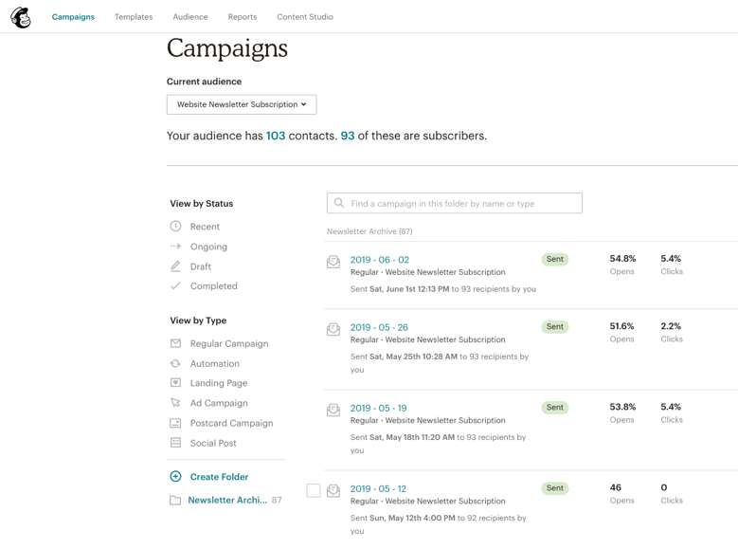
Start by logging in to www.mailchimp.com
- Username is ________
- Password is ________

Mailchimp often front-loads a page asking you to upgrade or calling for some other action.
“X” out to close and go to home page

Click on Campaigns
(Mailchimp’s name for e-newsletters)

Locate the previous week’s e-newsletter

We move our most recent e-newsletters to the Newsletter Archive Folder so it will be available on our website.
The Newsletter Archive will be highlighted in blue if it opens automatically.
If you don’t see the newsletter you’re looking for, click on Recent at the top of the sidebar

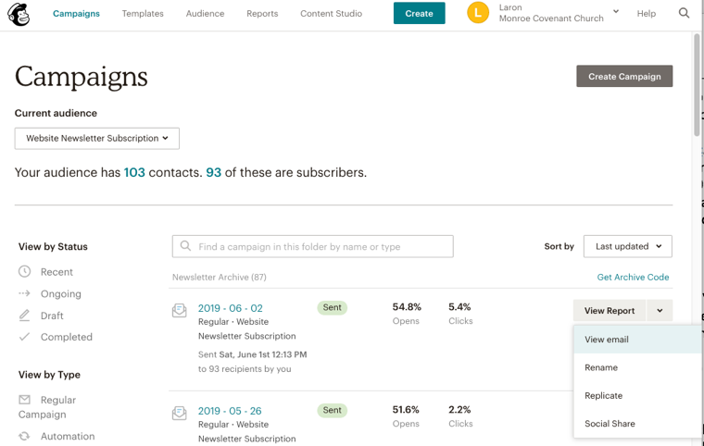
To choose the “campaign” you want to replicate (a previously sent newsletter)
Hover over the campaign block and from the drop-down menu Click Replicate

This will open a copy of the earlier e-news so you can edit and update it

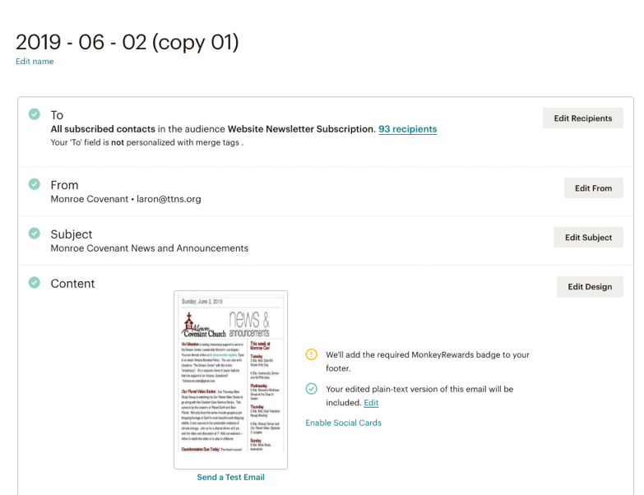
Edit Name, Click Edit name and update to YEAR – Month – Date (the Sunday this covers) and SAVE

If you want any replies to go to a different “From” address, you can edit that and insert the updated email address – subject can be edited if you are using this template for another purpose

To begin editing content, Click Edit Design

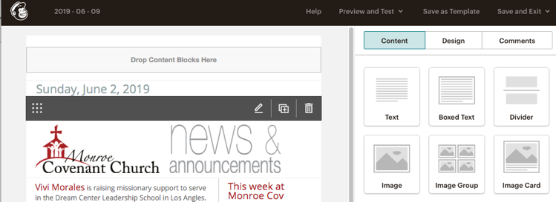
To edit an existing block, hover over the block and click the pencil tool
- The nine-dot block on the left side of the bar allows you to drag and drop this section to a new location
- The “+” sign duplicates the section
- The trash can does the obvious

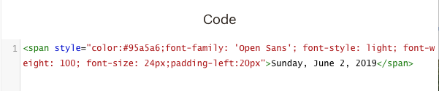
The date block is a Code Block
Click the pencil tool to edit the date inside of the code

Highlight the text to be edited and simply type the new date

Click the Save & Close Button at the bottom of the section

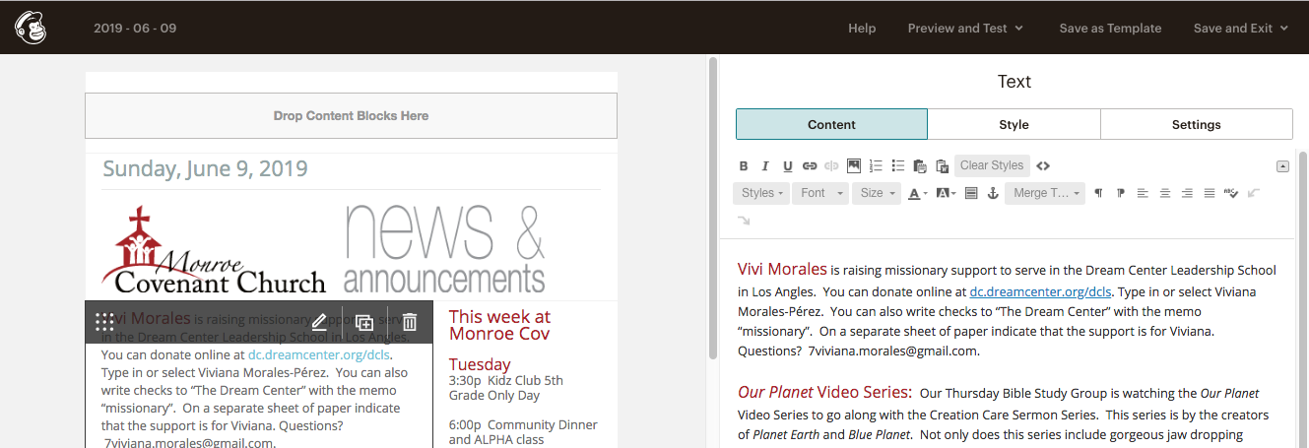
To edit the main (and other) text blocks,

Hover over the text block you’d like to edit and Click the pencil tool

The current text will appear in the right editing block. Editing the existing text is similar to editing in Word

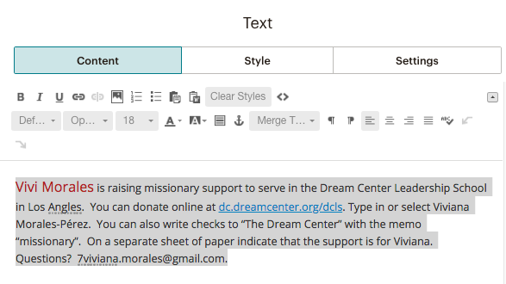
Tip You can simply highlight and type over to edit the existing text if there are few changes. Sometimes it’s just as quick to replace it all. The following instructions apply if you’re changing one item or the entire block.

Highlight the text to be edited or replaced – you can highlight the entire block

Type over the text

OR

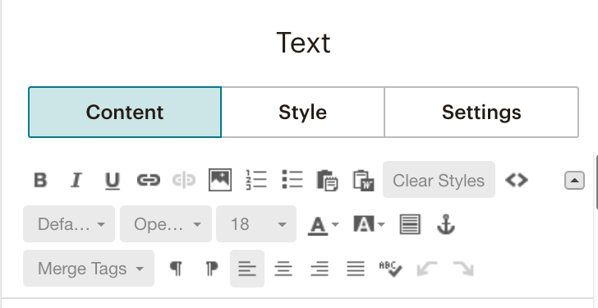
To paste in a large block of text:

- Copy the text you wish to insert into the e-news
(for instance from the Announcements section from Word version of bulletin)
- Highlight the text to be replace – from one item to entire block
- Click the Word/Clipboard icon
- Paste your copied text into the clipboard window and Click OK
This will copy rich-formatted text into the text block. This is necessary to remove any Word characters or formatting that may not translate into the electronic version of this email newsletter.
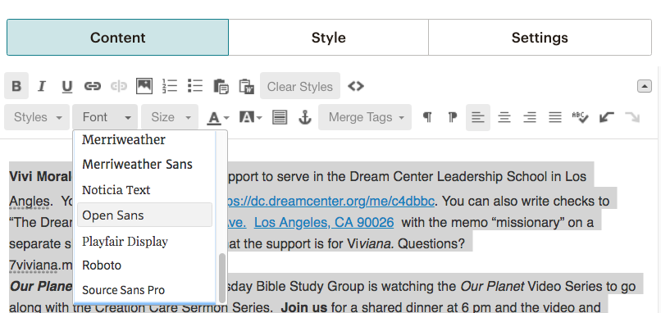
Now it’s time to clean up the text and make it look “pretty” for your readers

- Highlight the entire text block
- From the Font Drop-down choose Open Sans
- From the Font Size drop-down choose 14
- Click off Bold

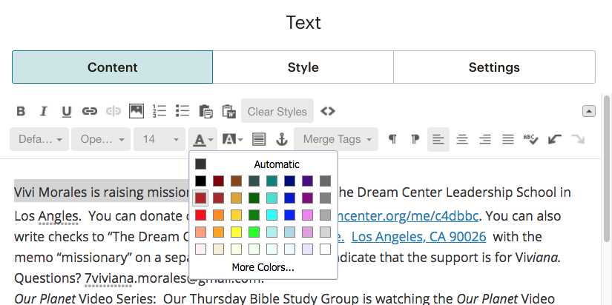
Format the text:
- Highlight the “headline” for each item
- From the Size drop-down choose 18
- From the Text Color selector choose dark red – Fire Brick
- At the end of each section, hit enter / return to separate paragraphs

Depending upon how you highlight (don’t include last space) the text to be “headlined”, you may need to reformat the remaining paragraph text to
size 14

When you’re finished editing this text block, Click the Save & Close Button

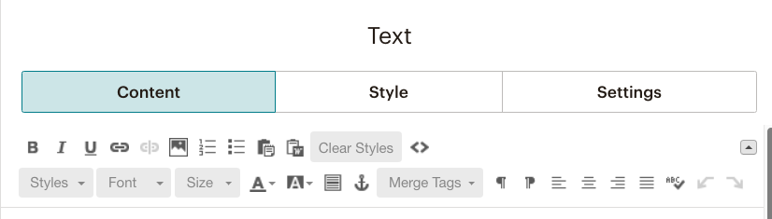
Formatting Text Tips

Link / Unlink
Link opens a pop-up window
Select from the drop-down:
- Web Address to link to a webpage
- Email address
- File if you want to upload a file to make a pdf, form,
document, etc. available for viewing and download You can insert a horizontal line You can insert an image (a better option follows)

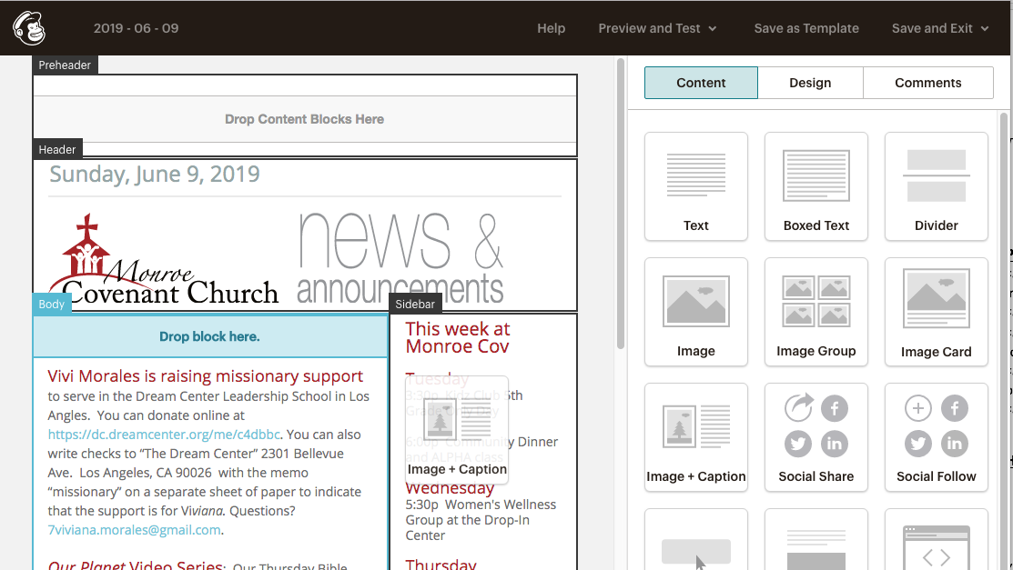
Even more…

You can add any of the available blocks to the
e-newsletter. Please don’t change or add social media icons or connections or the Give Online button.

To add a Content Block:

Drag and drop the Content Block into any “Drop block here” section

Tip Though you can insert an image directly into a text area by clicking on the image icon in the text editing bar, adding one of the Image Blocks will give you more control over the image

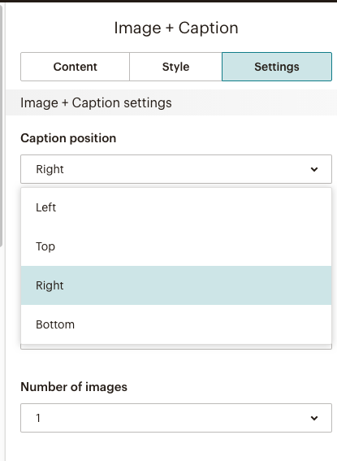
Working with Image Blocks
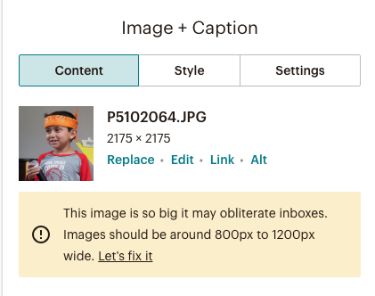
Image + Caption will likely be your most flexible and usable option
- Click Browse to use an existing picture or upload a new image
- Once you have selected your image and inserted it you can

- Edit – allows you resize and crop and also to adjust exposure, contrast, brightness, color, and much more – you don’t need to settle for bad picture – spend a little time to make your image pop
- You can also add a clickable link

To select the position of the picture relative to text Click Settings
- You can also resize the width of the picture and text by selection the Caption Width

Tip If you see a size error message as above, click fix it and resize the image (bottom left corner of editing frame) to not wider than 600 – that’s generally the entire width of the e-newsletter

Almost done…

In the top bar…

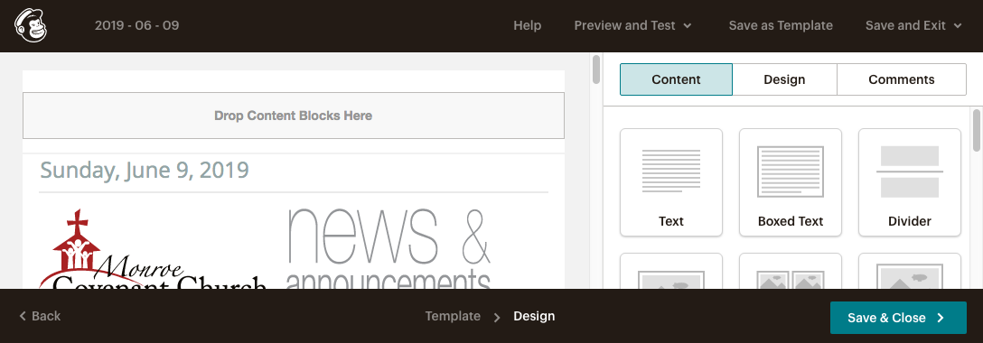
Preview and Test: clicking will allow you to view the email on a desktop, tablet, or mobile device (phone). You can also send yourself a test email if you’re concerned about formatting, etc.

Save and Exit: if you’re not able to finish editing at this time, you can save for later

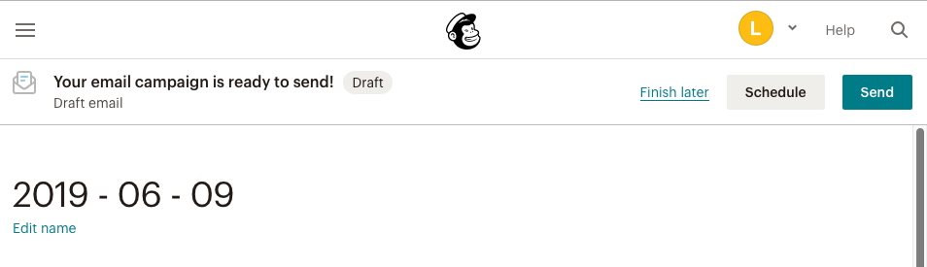
If you’re ready to send your e-news, Click Save & Close

Schedule is an additional chargeable upgrade – we still prefer free

When, you’re ready, Click Send – your e-news will send in just a few minutes.

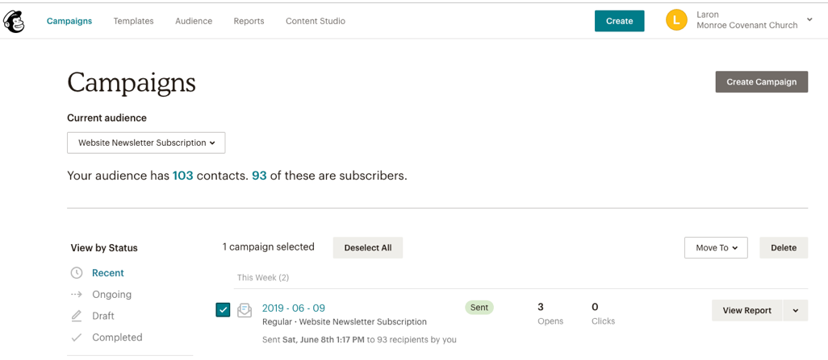
One last step – when you see the e-news has been delivered to your mail box (you shouldn’t have to sign out of MailChimp – it’s usually very quick):
- Go back to Campaigns
- Find the e-news you just sent (you might need to click on Recent)
- From the “Move to” drop-down, choose Newsletter Archive – that synchs this e-news from Mailchimp with our website homepage to keep it current
- Log Out from the Monroe Covenant Church drop-down and you’re finished!

